# **1 Introduction**

For many people, self-driving cars may seem like an impossibility, a vision of a distant future with an air of science fiction. However, many technology companies and vehicle manufacturers are joining efforts to make autonomous driving a reality closer and closer to us.

Following this technological trend, transport applications are also investing and betting on this promising future. Thus, some companies are promoting a competition to see which vehicle would be able to transport the greatest number of passengers in the shortest possible time.

# **2 General Objective**

Participants must build a robot capable of finding its way around, walking through the streets of the city, not colliding with obstacles, getting over the bumps, finding passengers, in addition to transporting them to pre-established locations with efficiency and agility.

# **3 The robots**

Teams will be able to build only one robot that must be capable of performing all the challenges proposed in the competition.

The maximum allowed size of the robot, on both categories, is 25cm high x 25cm wide x 25cm long with it fully developed and there is not a maximum number of parts, sensors and controllers for its construction. However, it is worth noting that it can only have parts from a single robotic kit. For example, if the chosen kit is the LEGO R Kit, no parts or accessories from any other manufacturer (Vex R, PETe R or FischerTechnik R) can be used. The robot must be totally autonomous, not allowing any type of external interference, unless the referee authorizes it.

However, it is worth highlighting that this year (2024), we will have two categories running simultaneously. The categories were divided between educational kits and free hardware. Therefore, during the description of the rules, be aware of the differences between the two categories. When registering teams for the event, the option will be available for each robot to participate in just one of the categories. The names of the categories became RoboCup Brasil Challenge KIT and RoboCup Brasil Challenge OPEN.

## 3.1 RoboCup Brasil Challenge KIT

The construction of the robots must follow the rules of the old SEK (Standard Educational Kit) category. So, they must only have parts from a single robotic kit. For example, if the chosen kit is the LEGO R Kit, no parts or accessories from any other manufacturer (Vex R, pETe R or FischerTechnik R) can be used.

## 3.2 RoboCup Brasil Challenge OPEN

The robots will be built using Free Hardware. There will be no restrictions regarding microcontrollers or microprocessors, not even the type of sensor, actuators and their quantities. The only restriction will be on the use of cameras or similar. Therefore, no type of image processing will be allowed.

An important observation is that, as this category is Free Hardware, teams will also be allowed to use educational kits, their parts or even sensors and actuators, without any type of restriction.

# **4 The Arena**

The arena will be made with banner canvas and printed using a standard file provided by the organization of the event. The printed colors must be closer to the RGB standard, to make it easier for the sensors to detect them.

The arena will be identical on both sides, in a mirrored way, so that there is no advantage between one side and the other of it.

In Figure 1, we can detail some areas and the objectives proposed in this challenge.

* PARK – Area represented in GREEN, with dimensions of 150x15cm;
* BAKERY – Area represented in BROWN, with dimensions of 27x24cm;
* SCHOOL – Area represented in BLUE, with dimensions of 27x24cm;
* DRUGSTORE – Area represented in RED, with dimensions of 24x24cm;
* CITY HALL – Area represented in GREEN, with dimensions of 24x24cm;
* MUSEUM – Area represented in BLUE, with dimensions of 27x24cm;
* LIBRARY – Area represented in BROWN, with dimensions of 27x24cm;
* STREET - Area represented in WHITE, with a maximum width of 30cm between establishments;
* BLACK LINES – They represent the boundaries between streets and establishments. They have a width of 3cm;
* YELLOW LINES – They represent the entrances of the establishments. They have a width of 3cm and a length of 15cm;
* RED LINES – They represent the end of the streets, as if they were dead-end streets. They have a width of 3cm and a length of 30cm;
* GRAY RECTANGLES WITH LETTERS – They represent the possible places where the match referee can place an obstacle (milk carton);
* CENTRAL WHITE STRIPE – It represents the passenger boarding area, but this year, an elevated platform with dimensions of 80x1500mm (WxL) and a height between 15 and 18mm will be placed. Therefore, all passengers will be on this White MDF platform, in a random, but equal way, between the two halves of the lane. So, to be clear, we will not have markings of possible locations where the tubes will be. Their positioning will be at the discretion of the match referee, as long as the maximum dimension of the tube (5cm in diameter) is completely on top of the platform. The passengers will be represented by PVC tubes detailed below.

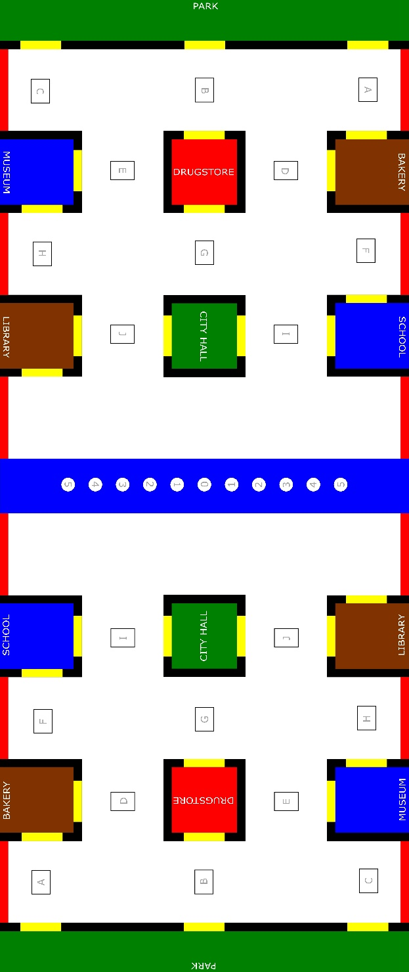

Figura - Top view of the complete arena

As the arena is symmetrical and represented in a mirrored way, we will detail only one of the halves, with the positions and dimensions in a more complete way.

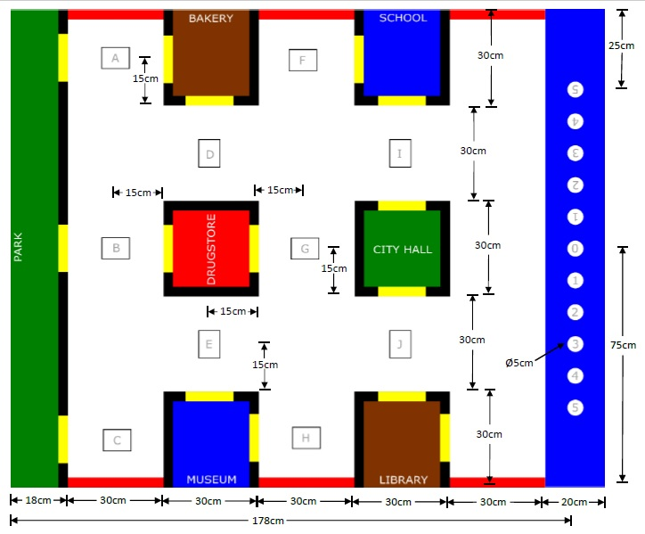

Figure - Top view of the half of the arena with dimensions

**5 The Passengers (tubes)**

The tubes are standard PVC tubes for piping of 5cm (approximately 2 inches) in circumference and in two different lengths. These tubes will represent people waiting to be transported to their specific location, which will be detailed below. The lenghts of the tubes will be **10cm** (to represent children) and **15cm** (to represent adults). All tubes will be covered with adhesive paper with the colors BLUE, GREEN, RED and BROWN, only on the outer surface of the tubes.

Three (3) units of each tube size and color will be made available. Therefore, we will have **up to** 3 tubes of each type in each match. Thus, the referee will have at his disposal 3 tubes of 10cm and 3 tubes of 15cm in blue, 3 tubes of 10cm and 3 tubes of 15cm in green, 3 tubes of 10cm and 3 tubes of 15cm in brown and only 3 tubes of 15 cm in red.

This year we will have something new, white tubes (original color of the tube or covered with white adhesive paper) measuring 10cm and 15cm, which represent people who DID NOT request a ride on the transport app. The quantity rule will be the same as for the other tubes, with each match being able to have up to three 10cm long tubes and/or three 15cm long tubes.

# **6 Bumps**

It will be possible to use bumps during the matches. The rules for using these bumps will be similar to those used with obstacles. Therefore, these speed bumps can be placed before or during the match. It will also be possible

to use up to three speed bumps on each side of the lane. These bumps will be 300mm long and 10mm high, with a 30° inclination, as shown in the figure below (The file will be made available so that teams can print in 3D).



*Figure 3 - Front view and side view of half of the bump*

Com relação aos possíveis posicionamentos dessas lombadas, para não atrapalhar as entradas dos estabelecimentos, será definido que as lombadas estarão centralizadas em relação as paredes (linha preta). Portanto, teremos 20 possíveis posições conforme a figura abaixo.

Regarding the possible positioning of these bumps, so as not to obstruct the entrances to the establishments, it will be specified that the bumps will be centered in relation to the walls (black line). Therefore, we will have 20 possible positions as shown in the figure below.

Figure 4 - Track with possible locations where there may be bumps

# **7 The matches**

Each of the teams will compete on one side of the city, aiming to drive as many passengers (tubes) to their predefined locations.

The team that obtains the highest score (scores available in Section 7) will be determined the winner.

Each match will have at least one referee, who will be responsible for writing down the scores and managing the passengers during the dispute.

All robots start in a random position, on some street (white area) and anywhere in the city, placed by the referee, always aiming for symmetry between the teams.

Robots on one side of the city will not be allowed to enter the limits of the other side. Therefore, the areas that represent the streets (white area) can only be occupied by one robot on each side.

As we will have an elevated platform in the center of the track, robots will NOT be allowed to climb and move over the platform.

If an opposing robot crosses the boarding area and enters the streets (white area) on the other side of the city, it will be considered a lost robot. It must be returned to its place of departure.

It will also be considered a lost robot when it exceeds the city limits (356x150cm), represented by the red lines or the limits of the colored areas of the establishments.

The central strip, represented in blue, with the MDF platform placed centrally, will be the passenger boarding area. For teams that have the canvas printed with the old file, the 11 circles with a diameter of 5cm will be located under the platform, so, they will not be used as possible places where there may be passengers (tubes) waiting for the vehicles. However, the new file, available on the event's official website, does not have these circles, just the boarding location in blue, 200mm wide and a centralized white stripe measuring 80x150mm.

For a better approximation with reality (as the tubes represent people), all tubes will be positioned **upright** (vertically) in the boarding area.

The number and disposition of passengers in the boarding area will be defined by the referee before or during the match.

A passenger will be considered successfully delivered when the tube is completely inside the colored area and upright, with no part touching the black and/or yellow lines.

If the tube does not stand anywhere on the lane, it will be considered a lost tube. The referee must place it where it was at the start of the game.

If the robot knocks down the tubes that were already correctly positioned before, or moves them to a prohibited position, the previous score will be affected (scores and description are available in Section 7) and the affected tube will be immediately returned to the boarding zone by the referee.

During the match, in the boarding area, if the robot tries to pick up the passenger without success or accidentally moves the tubes, it will be considered a lost tube. Thus, the team will suffer a penalty described in the score (scores available in Section 7) and the tube will be immediately replaced by the referee.

Robots will not be allowed to leave the streets (white area) and invade any establishment (limited by color sensors). Example: The robot cannot go inside the Bakery area (brown), even partially, to reach the Park. Therefore, the robots will have to move around the city using the streets (white area) and as a reference, the black, red and yellow lines that are the limits. Except when picking up or dropping off passengers at the defined locations.

The yellow lines represent the entrance to each establishment. Therefore, only the passenger who is released in the colored area will be considered valid, provided that the passenger has entered the place passing, entirely, between the limits of the yellow line.

For establishments that have two entrances, there will be no difference in the score between them, so the robots can use any of the entrances marked with the yellow line.

With regard to establishments that have two entrances, robots will not be allowed to cross the premises by entering on one side and leaving on the other. In this case, the robot will be considered lost and must return to the starting point of the match.

The rectangles identified with letters from A to J, will be the places where the referee **may** place an obstacle. This obstacle will be represented by a milk carton, with no defined color, which has approximate dimensions of 16x9x7cm. A maximum of three obstacles are predicted on each side of the arena. These obstacles can be placed before or after the start of the game.

In case the robot does not identify the obstacle and moves it or even knocks it down, the team will suffer the penalty of unidentified obstacle. In this case, the obstacle will be repositioned and the robot will have to return to the starting point.

The idea for placing these obstacles, before or during the match, is precisely to simulate a possible accident or something that makes it impossible for vehicles to drive through the street. Therefore, when the referee places an obstacle in a certain place, it is predicted that the robot will not be allowed to try to pass through the street or try to place a passenger through the blocked entrance. With this possibility, the teams must be prepared to “recalculate the route” and look for the other entrance(s) of the establishments.

It is also predicted that the referee will not be allowed to place the two obstacles closing the two entrances of any establishment.

Every time a team has problems with the robot and needs to touch it, reposition it, restart the program, reassemble a loose part or if it just has a "bug", it will be considered as a restart.

When one of the teams finishes, successfully, placing the last tube in the correct place, the match will automatically be considered over.

The referee will be allowed to place, remove or just change tubes at the boarding place, even after the start of the match, positioning them in the spaces intended for passengers, in a symmetrical way.

The maximum time for each match is **12 minutes**.

Negative scores will not be counted, so no team will have a score below zero.

When getting close to the end of the match and the referee identifies that there is a tie in the overall score (positive scores and different from zero), he must add up to 3 minutes (overtime). Within that time, the first team that performs a task that adds a POSITIVE score will be considered the winner. In case of overtime is added on, after 15 minutes (12 minutes of the match + 3 of overtime), if no team manages to have a positive score, the match will be decided by the tiebreaker criteria of the score of 0x0 (zero to zero).

If the match ends with overall scores of 0x0 (zero to zero), the following tiebreaker criteria will be considered to define the winning team, in order of importance:

* 1°- The team that achieves the highest positive score will be considered the winner;
* 2°- If the positive score is the same, the team that obtained less negative scores will be considered the winner;
* 3°- If none of the teams manages to perform any task that adds up to a positive score, the match will be considered a tie (classification phase);
* 4°- It is predicted that (as the last option), if the match is in a phase of the competition where it is essential to define a winning team (knockout), the referee will be responsible for analyzing and interpreting the performance of the robots during the match. Thus, the winner will be considered the one that comes closest to achieving the proposed goals. This analysis will be carried out together with the captains of the participating teams.

The color, size and destination of the passengers are defined as follows:

⮚ 10 cm long BLUE tube: Represents the children who will go to SCHOOL;

⮚ 15cm long BLUE tube: Represents the adults who will go to the MUSEUM;

⮚ 10cm long GREEN tube: Represents the children who will go to the PARK;

⮚ 15cm long GREEN Tube: Represents the adults who will go to the CITY HALL;

⮚ 10cm long BROWN tube: Represents the children who will go to the LIBRARY;

⮚ 15cm long BROWN tube: Represents the adults who will go to the BAKERY;

⮚ 15cm long RED tube: Represents the adults who will go to the DRUGSTORE;

⮚ 10cm or 15cm long WHITE tube: Represents children or adults who have not requested the transport service and should not be removed from the platform by the robots;

**7.1 End of a Match**

There are four ways to declare the end of a match:

* **Time-out:** the 12 minutes time expires. So, the team with the highest score at the end of the time will be declared the winner.
* **Give-up:** one of the teams gives up the match. So, the opposing team is immediately declared the winner.
* **Overtime:** If the match is ending in a tie and with positive scores, the referee will add up to 3 minutes of extra time. Within that time, the team that accomplishes any objective that adds up to a positive score will win.
* **Match completed:** when all passengers are delivered to destinations correctly. So, the team with the highest score at the end of the challenge will be declared the winner.

# **8 The Scores**

* Each 15cm RED tube successfully placed: **50 points**.
* Each 15cm BROWN tube successfully placed: **45 points**.
* Each 15cm BLUE tube successfully placed: **45 points**.
* Each 15cm GREEN tube successfully placed: **42 points**.
* Each 10cm GREEN tube successfully placed: **40 points**.
* Each 10cm BROWN tube successfully placed: **37 points**.
* Each 10cm BLUE tube successfully placed: **37 points**.
* Each WHITE tube, unidentified by the robot's sensors and completely removed from the boarding platform, will be considered as a wrong passenger: - 8 points.
* Each lost tube (specified in Notes): **-3 points**.
* If it is identified that, when entering the establishment, the robot has not guided the tube completely over the yellow strip, this tube will be considered lost, even if it is placed correctly.
* If one of the teams places a tube correctly and, during the match, tries to place another tube in the same establishment, the team will not suffer punishment as long as the robot does not knock over the previous tube or move it to a prohibited position (see description of the tube considered lost). But if the robot knocks over the tube or moves it to the point of removing some part of the tube from the colored area, **15 points** will be deducted from the previous score and the penalized tube will be repositioned in the boarding area.
* The robot will not be allowed to drop the passenger, even temporarily, anywhere other than in the colored area of the establishments. If this happens, it will be considered a lost tube.
* Every time a robot exceeds its permitted delimited area or leaves the lane: **-3 points** and the robot will be replaced in the place established by the referee of the match.
* Unidentified obstacle: **-4 points**.
* Each restart of a robot: **-7 points**.
* Each repositioning of tubes, in the collection area, during the match: **-3 points**.
* Each tube placed correctly, but in wrong places, will be considered a lost tube. The referee must immediately remove the tube from the establishment and place it in the initial location (boarding area), so as not to harm the other team.
* Inactive robot: -**7 points**.

# **9 Notes**

* A tube is considered successfully delivered when it is static, upright and completely in the colored areas of the establishments.
* A tube is considered lost when it is completely removed from the platform and dropped in any other position, except in the colored areas of the establishments.
* A robot is considered inactive when it is stationary or making any other movement that does not characterize inspection of the boarding area, tube collection, self-locating, or any other movement that characterizes the intention of achieving the objectives of the challenge.
* If any robot clearly demonstrates that it is not trying to perform any of the challenges (in order not to make a negative score), it will be considered an inactive robot.
* If the team decides to leave the robot inactive or remove the robot from the dispute on purpose (with the clear intention of not having more negative scores), for a period longer than 1 minute, it will be considered a withdrawal and the opposing team will be considered the winner.

# **10 Participation requirements**

Those interested in participating in the LARC IEEE SEK Latin American Robotics Competition must form teams of undergraduate students from any educational institution in any country. However, high school students will also be able to participate. To apply, teams must submit a document describing the development and operation of the robot (TDP) in IEEE format. This TDP will be used for the winners to make a brief report to the other competitors. Please check the deadlines on the event website.

# **11 The jury**

JURY is composed of a member of the organizing chairs, an assistant from the organization and a member of another team that is not competing in the match, chosen before the start of the match.

# **12 Extraordinary situations during the competition**

If there is any situation not covered in the above-mentioned rules, or any doubt about the score, it will be up to the judges and competition organizers to consider the case as impartially as possible and make a decision. It is important to mention that any fact that is not explicit in the rules cannot be automatically considered admissible in the competition. Omitted facts will always be treated as an extraordinary situation and must be judged as admissible or not by the judges and organization.